
Product user manual analysis
Haylou Wireless Earbud user guide

Arham Khan 22k-4080
Aarib Ahmed 22k-4004
Masir Ali Khan 22k-8702

Audience and Purpose Analysis

Audience Identification

The Haylou GT5 True Wireless Earbuds manual has a variety of intended audiences:
- Consumers: They encompass everyone from those highly knowledgeable about technology to newcomers looking for their first pair of wireless buds. These individuals want to unpack, set up, and use their new purchase safely and effectively.

- Customer Support Teams: Representatives aim to help a diverse range of users. Their mission is addressing any issues that arise as well as guiding people through all the ins and outs of enjoying audio wirelessly. Deft communication skills allow addressing the entire spectrum of technological proficiency.

- Retail Employees: Shoulder the duty of selling prospective customers on features while also ensuring they understand what they're getting themselves into. Whether answering questions about sound quality, battery life, or ease of use, sales staff hope to provide clarity that leaves shoppers feeling confident in their choice.

So audience for the Haylou GT5 Wireless Earbuds user manual is general consumers who have purchased or are using the product. This audience may range from tech-savvy individuals to those with minimal technical experience.

Purpose of the Manual

- The manual offers a detailed yet easy-to-follow guide for utilizing all the earbuds' capabilities. Step-by-step pictures and explanations walk users through powering on the earbuds, pairing with devices via Bluetooth, and charging safely to take full advantage of their features comfortably.
- Included is an extensive troubleshooting section addressing common glitches that may unexpectedly arise. Both consumers and customer support representatives can rapidly diagnose and solve issues like intermittent disconnections, or distorted sound quality.
Overall, primary purpose of this manual is to provide instructions for setting up, using, and maintaining the wireless earbuds.
    - The first 4 pages explains the first use, charging, and pairing process for the earbuds. Then there are details on how to use the touch controls to perform functions such as playing music, making calls, and activating the voice assistant.
    - There are some troubleshooting instructions that offers solutions to common issues such as earbuds not charging or connection problems.

Gap Analysis

Layout

- The manual includes basic sections such as product introduction, operation instructions, and troubleshooting, but lacks a Table of Contents. The layout is mostly linear, and important sections (e.g., pairing instructions, charging details) are not clearly demarcated.
- Illustrations are included but are not highly intuitive or easily understandable, which might cause confusion.
- While sections are defined, the manual's design fails to engage user. Back Cover is also missing. For instance, depictions of earbuds, charging, and pairing offer clarity but ‘How to Use’ lacks Clarity.
- Recommendation: Bulleted summaries and highlighted quick guides may boost comprehension. Incorporating illustrations for simple specifications and steps (e.g. adding GIFs instead of text). Reorganizing breaks up uniform blocks of text. This refreshes boring presentation, drawing users into the material.
For e.g. for manually pairing the earbuds, pictures can be added for illustrations.
No images to manually pair with the phone
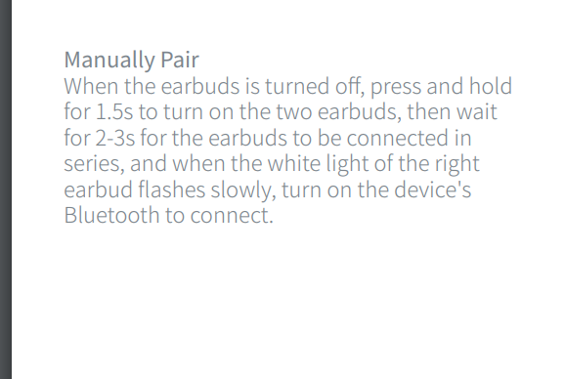

Language and Tone

- The speech in the handbook tends to be direct and specialized, which can work for clients more accustomed to innovation but may segregate individuals less familiar with technology.
- The manual is written in English, but the language level is basic enough to be understood by non-native speakers but can be annoying for casual client due to excessively specialized language manner.
- Recommendation: Use a more amicable tone that simplifies technical jargon. Giving clarifications for terms or including a glossary would make the guide open to a more extensive crowd.

For e.g, jargons in the ‘Switch Operation’ Section:
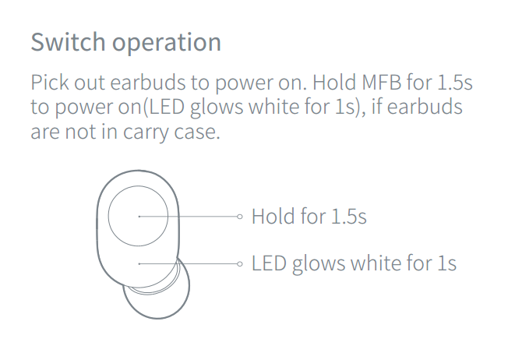
What is ‘MFB’?
These jargons should be removed.

Usability

- The manual thoroughly outlines available options, and functionality yet lacks organizational aids. Key sections like the charging process and Bluetooth pairing are not prominently featured or highlighted (e.g. using different colours for section heading)

- Recommendation: Add a thorough table of contents at the beginning and a back-of-book indexing system to enhance functionality. This enables customers to swiftly find what they need, making the manual easier to use and bettering the overall user experience.

Accessibility

- The handbook is found in a standard PDF format, which might not be suitable for all clients. Individuals with visual incapacities may face difficulties obtaining the within information. The current delivery method risks insufficient consideration of readers who could benefit most.

- Recommendation: Providing the manual in multiple configurations (like audio, Braille, or enlarged print) and confirming it follows norms for accessibility would help guarantee inclusiveness. Modernizing the manual's delivery through additional formats could extend its rewards to a broader range of users and circumstances.
For e.g. Adding hyperlinks to contact customer support.

Missing hyperlinks (may create difficulties for hearing aid)

